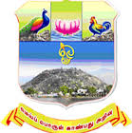 | ARULMIGU PALANIANDAVAR COLLEGE OF ARTS AND CULTURE  (Reaccredited with “A” Grade by NAAC),  Run by Arulmigu Dhandayuthapani Swamy Thirukoil, H.R. & C.E. Dept., Government of Tamil Nadu  A Government Aided College - Affiliated to Madurai Kamaraj University, Madurai  Dindigul Road, Palani - 624 601 | 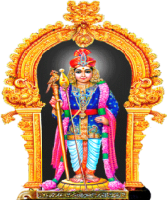

STUDENTS FEEDBACK FORM

Academic year : Department :
Class :

(Please fill the appropriate box with tick mark (✓))

S.No. | Description | Excellent | Very Good | Good | Average | Below Average
1 | Completion of the syllabus as prescribed by the university
2 | How do you rate the contents of the curricular?
3 | How do you rate lab facilities?, if applicable
4 | Uses of innovative teaching methods
5 | Helps students facing physical, emotional and learning challenges
6 | Approach towards developing professional skills among students
7 | Helps students in realizing career goals
8 | Inspire students for ethical conduct
9 | Availability of Library Resources
10 | Regarding Co-Curricular/Extra Curricular Activities
11 | Training and Placement Activities
12 | Effectiveness of teacher in terms of
i | Technical content
ii | Communication skills
iii | Use of Non print teaching aids
iv | Availability beyond normal classes and co-operation to solve individual problems

Your suggestions for the improvement of the Institution

Name and Signature of the student (optional):

