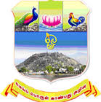 | ARULMIGU PALANIANDAVAR COLLEGE OF ARTS AND CULTURE  (Reaccredited with “A” Grade by NAAC)  Run by Arulmigu Dhandayuthapani Swamy Thirukoil, H.R. & C.E. Dept., Government of Tamil Nadu  A Government Aided College - Affiliated to Madurai Kamaraj University, Madurai  Dindigul Road, Palani - 624 601 | 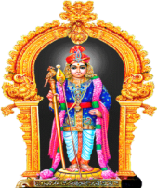

TEACHERS FEEDBACK FORM

Academic year :
Department :
Name of the Teacher :
(Please fill the appropriate box with tick mark (✓))

S.No | Description | Excellent | Very Good | Good | Average | Below Average
1 | Syllabus is suitable to the course
2 | Aims and objectives of the syllabi are well defined and clear to teachers and students
3 | The course/syllabus has good balance between theory and Lab
4 | The course/program of studies carries sufficient number of optional papers
5 | The books prescribed/listed as reference materials are relevant, updated and appropriate
6 | Syllabus provides an opportunity to enter into research
7 | Syllabus helps to meet the global challenges

Suggestions, if any

Signature of the Teacher

